**Mid Term Paper FALL**-2019

**BSSE (Morning)**

**Computer Networks ( CS-577 )**

**Maximum Marks: 18 Total Time: 1.5Hr**

**Instructions: Attempt all Questions and solve all parts of a Question together in a sequence.**

**Question N0. 1 (10min) [Marks: 2]**

Which layer of OSI model is responsible for the following functionalities:

Translate Data, Routing, Encryption, Synchronization, Framing, Error Control with ARQ, Forwarding, CRC.

|  |  |  |  |  |
| --- | --- | --- | --- | --- |
| SrcMac | DesMac | SrcIP | DesIP | Data |
|  |  |  |  |

**Question N0. 2 (15min) [Marks: 4]**

Complete the packet information at each in and out of each device. Addresses are given below:

ComputerA IP:50 ComputerA Mac:110

RouterR1 IP:60 RouterR1 FromMac:111 RouterR1 ToMac:210

RouterR2 IP:70 RouterR2 FromMac:211 RouterR2 ToMac:240

ComputerB IP:80 ComputerB Mac:241

**Question N0. 3 (15min) [Marks: 2+2]**

Four TV channels having nonperiodic composite signal has a bandwidth of 400 kHz each. The first channel has a middle frequency of 500 kHz and peak amplitude of 20 V. The two extreme frequencies of each channel have an amplitude of 0. There is a gurad band of 100kHz between each channel.

1. Write down the lowest, highest and peak frequencies of each channel.
2. Is the bandwidth for one channel is sufficient for a black and white TV having 300 x 200 resolution with 30 frames per second and 2 pixcels per cycle?

**Question N0. 4 (15min) [Marks: 2+2]**

1. The loss in a cable is usually defined in decibels per kilometer (dB/km). If the signal at the beginning of a cable with −0.4 dB/km has a power of 3 mW, what is the power of the signal at 8 km?
2. If the distance between 2 routers is 15000 km and the propagation speed is 2.4 x 10^8 m/s and image of size 1MB is being sent on a bandwidth of 2Gbps. Then what is the total delay (transmission and propagation time to reach complete data) from one router to other router.

**Question N0. 5 (20min) [Marks: 2+2]**

1. Draw the flow diagram of CSMA/CD
2. Complete the following figure if Frame1 lost and sender sends frame 2,3 and 4 before it knows about loss of Frame1.

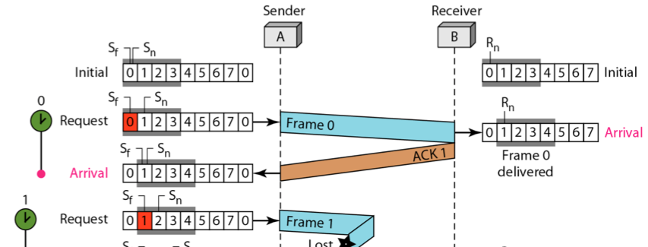

**\*\*\*\*Good Luck\*\*\*\*\***